電腦網路與通訊基礎 Homework #4

- [P7-21] (20%) An ISP is granted the block 80.70.56.0/21. The ISP needs to allocate addresses for two organizations each with 500 addresses, two organizations each with 250 addresses, and three organizations each with 50 addresses.
- Find the number and range of addresses in the ISP block. (5%)
- Find the range of addresses for each organization and the range of unallocated addresses. (10%)
- Show the outline of the address distribution and the forwarding table. (5%)

- [P7-23] (10%) Can router R1 in Figure 7.35 receive a packet with destination address 140.24.7.194? What will happen to the packet if this occurs?

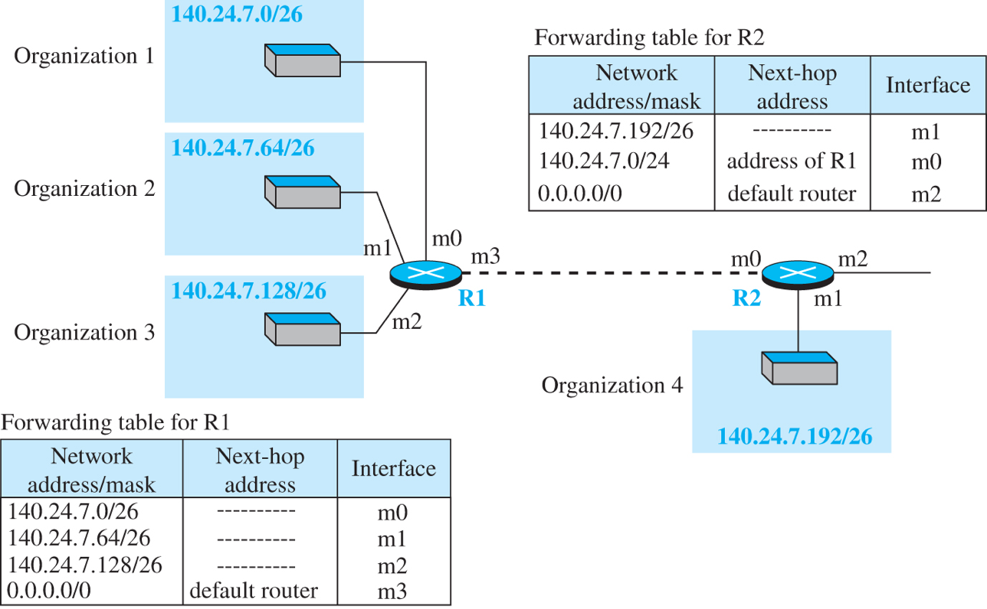

- [P7-24] (10%) Assume router R2 in Figure 7.35 receives a packet with destination address 140.24.7.42. How is the packet routed to its final destination?

- [P7-25] (10%) In an IPv4 datagram, the value of the total-length-field is (00A0)₁₆ and the value of the header-length(HLEN) is (5)₁₆. How many bytes of payload are being carried by the datagram? What is the efficiency (ratio of the payload length to the total length) of this datagram?

- [P7-26] (10%) An IP datagram has arrived with the following partial information in the header (in hexadecimal):
45000054 00030000 2006…
- What is the header size?
- Are there any options in the packet?
- What is the size of the data?
- Is the packet fragmented?
- How many more routers can the packet travel to?
- What is the protocol number of the payload being carried by the packet?

- [Chap8] (20%) Using Dijktra’s algorithm, create the shortest path tree and the forwarding table for node B (i.e. B is the source node) in the following figure. You should show the least-cost tree in each iteration of the algorithm.
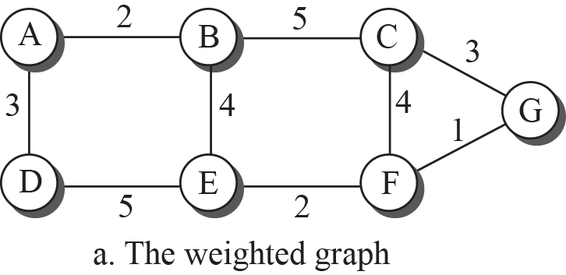

- [P8-5] (20%) In distance-vector routing, good news (decrease in a link metric) will propagate first. In other words, if a link distance decreases, all nodes quickly learn about it and update their vectors. In the following figure, we assume that a four-node internet is stable, but suddenly the distance between nodes A and D, which is currently 6, is decreased to 1 (probably due to some improvement in the link quality). Show how this good news is propagated, and find the new distance vector for each node after stabilization. ‘
